Assignment 1

(The csv file competitorList needs to be in the project folder).

# 1. Decisions

## 1.a Extra Attributes

Competitor info:

* Location
* Favourite knit

Statistics:

* Total of all scores
* Average of all scores
* Number of competitors in each experience category

## 1b. Overall Score

The overall score was calculated by taking each competitors’ highest three scores and averaging those.

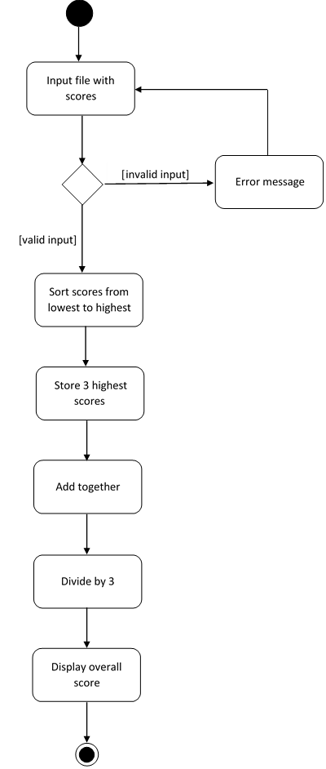

# 2. Status Report

This application meets the specification almost completely. However, the method for calculating the frequency could be more succinct.

|  |  |  |
| --- | --- | --- |
| Limitations | |  |
| Problem | **Effect** | **Reason not addressed** |
| Extra scores are provided in the input file | Assumes this won’t happen, no checks made. Programme will store the extra score and will affect the totals, averages and counts but will not affect the display or overall score / winner. | Time limitations |
| A name with greater than 40 characters in provided in the input file | Assumes this won’t happen, no checks made. The name will be accepted but the table display will be distorted. | Time limitations |
| A name is provided in the input file which has more than one middle name | Assumes this won’t happen, no checks made. The name will be accepted however the initials will only provide the first middle name. | Time limitations |
| The favourite knit provided in the input file is greater than 60 characters | Assumes this won’t happen, no checks made. The table display will be distorted. | Time limitations |
| The experience provided in the input file does not fall under Beginner, Intermediate or Expert. | Assumes this won’t happen, no checks made. Will not be included in the count of Experience. | Time limitations |
| The location and experience provided in the input file is greater than 20 characters | Assumes this won’t happen, no checks made. The table display will be distorted. | Time limitations |
| Grammar in full details if the competitor experience is Beginner | Doesn’t account for the use of a / an before “Beginner”, “Intermediate”, “Expert”. Grammatically incorrect if the competitor is a Beginner. | Time limitations |

|  |  |  |
| --- | --- | --- |
| Tests | | |
| Test | **Tested** | **Passed** |
| Full details are provided for each competitor even if they all have the same highest overall score | * one competitor with the highest overall score * two competitors with the highest overall score * three competitors with the highest overall score | Yes |
| Initials are returned for a name with and without middle name | * Betty Anne Harris => BAH * Bernie Bob Horton => BBH * Gertrude Malone =>GM * Danny MacDonald => DM * Felicity Francis Fernando => FFF * Pennyghael Wise => PW * Frank Malone => FM * Kermit Les Amphibian => KLA * Jennifer Wilson => JW * Henrietta Annabelle Carstairs => HAC * Vole Dee Mort => VDM * Mary Anne Poldark => MAP * Casper Cordelius Specter => CCS * Sorrel McKenzie => SM * Holly Fearne Beane => HFB | Yes |
| Scores provided on input file are within range 1 to 5, error message if not | 3,5,5,4,3  2,2,4,3,2  4,5,2,4,3  3,2,1,3,2  4,2,4,3,2  5,4,5,3,5  3,4,2,4,3  4,5,5,5,4  **8,9,6,2,3**  4,5,2,4,3  2,2,1,1,3  5,5,4,4,3  4,5,2,5,3  4,4,3,4,3  3,4,3,2,3  **2,2,1,b,3** | Yes |
| Scores missing from input file are caught, error message if missing | 3,5,5,4,3  2,2,4,3,2  4,5,2,4,3  3,2,1,3,2  4,2,4,3,2  **5,4,5**  3,4,2,4,3  4,5,5,5,4  2,4,3,2,3  4,5,2,4,3  2,2,1,1,3  5,5,4,4,3  4,5,2,5,3  4,4,3,4,3  3,4,3,2,3 | Yes |
| Competitor found using competitor number, returns details if valid, error message if not | * 100 to 114 - all found * 77 – not found * 409 – not found * 7000000 – not found | Yes |
| Competitor number input is valid, display error message if not | * g – invalid * -9 – invalid * 115 – invalid * 105 – valid * 114 - valid * banana – invalid | Yes |
| Highest overall score is correct | * 5.0 * 4.9 * 3.8 | Yes |
| Total of all scores is calculated correctly | * sum of:   3,5,5,4,3,2,2,4,3,2,4,5,2,4,3,3,2,1,3,2,4,2,4,3,2,5,4,5,3,5,3,4,2,4,3,4,5,5,5,4,2,4,3,2,3,4,5,2,4,3,2,2,1,1,3,5,5,4,4,3,4,5,2,5,3,4,4,3,4,3,3,4,3,2,3  = 252   * sum of:   3,3,2,3,3,2,3,1,3,2,5,5,3,4,3,3,2,1,3,2,5,5,5,3,2,5,4,5,3,5,3,5,1,4,3,4,5,5,5,4,2,4,3,2,3,4,3,2,3,3,2,2,1,1,3,5,5,4,4,3,1,2,3,5,2,4,4,3,4,3,3,3,3,2,3  = 241 | Yes |
| Total average of all scores is calculated correctly | * 252 / 15 = 3.36 * 241/15 = 3.21 | Yes |
| Number of competitors is calculated correctly | * input list with 15 competitors * input list with 20 competitors * input list with 5 competitors | Yes |
| Highest / Lowest score awarded | High: 4, 5, 3  Low: 1, 2, 4 | Yes |
| Number of competitors in each experience category | Beginner: 4  Intermediate: 5  Expert: 6  Beginner: 0  Intermediate: 7  Expert: 8 | Yes |
| Frequency of scores | 1: 3  2: 16  3: 21  4: 21  5: 14  1: 3  2: 20  3: 19  4: 20  5: 13 | Yes |
| Catch name missing from input file | Excluded name of competitor | Yes |
| Catch write file not found |  | Yes |
| Catch no text to write to file | input empty csv file | Yes |
| Catch read file not found | misspelled file name | Yes |
| Catch part of name missing | Excluded middle name and last name | Yes |
| Overall score calculation is correct | * 5.0 * 4.7 * 3.7 | Yes |
| If cancel selected on GUI, catch exception and system exit | select cancel | Yes |
| Ask if want to search again yes no | select different options | Yes |

|  |
| --- |
| Bugs |
| No known bugs |

# 3. Diagrams

3a. Class Diagram

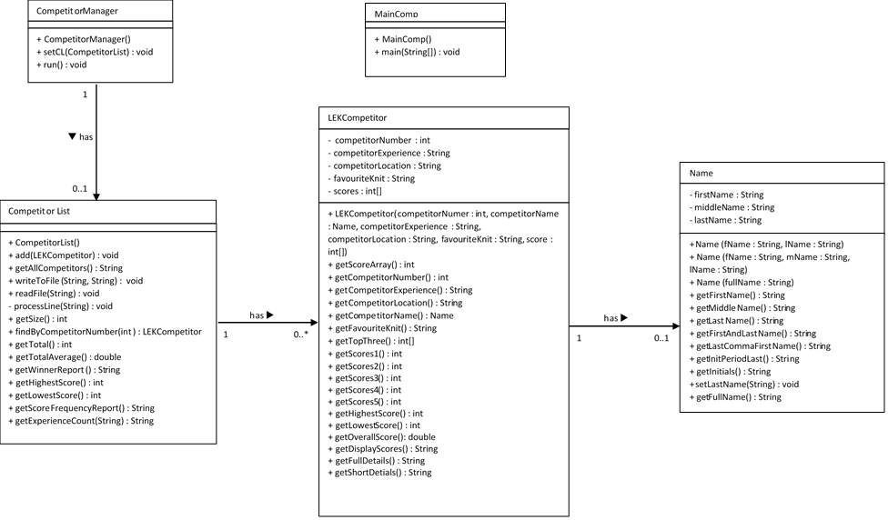

3a. Sequence Diagram: Finding the competitor number

